
Sukkur IBA University
Department of Computer Science
Compiler Construction Lab

Lab # 01: Lab 1: Introduction to Compiler Construction Tools
Instructor: Muhammad Ismail Qureshi
Submission Profile
Name: Submission date (dd/mm/yy):
Marks obtained: Receiving authority name and signature:
Comments:
________________________________________________________________________________
Instructor Signature

Note: Submit this lab hand-out on LMS/e-learning before the next lab with attached solved activities and exercises

Lab Learning Objectives:

Upon successful completion of this experiment, the student will be able:
- Understand the core phases of a compiler and the translation pipeline.
- Set up a C development environment (GCC, VS Code/Code::Blocks).
- Grasp fundamental programming language concepts: State, Environment, Scope, and Binding.
- Implement scope resolution rules and track variable lifetimes in C programs.
Lab Hardware and Software Required:
• GCC Compiler (MinGW for Windows or native GCC on Linux/macOS)
• Visual Studio Code / Code::Blocks / C IDE
• Command Line Interface (Terminal/CMD)
• PC
Background Theory:

1. Introduction to Compiler Phases
A compiler translates high-level source code into low-level machine code through structured phases:
- Lexical Analyzer (Scanner): Converts characters into tokens (keywords, identifiers, operators).
- Syntax Analyzer (Parser): Checks grammatical structure and builds a Parse Tree or Abstract Syntax Tree (AST).
- Semantic Analyzer: Ensures type consistency, valid scope rules, and context accuracy.
- Intermediate Code Generator (ICG): Produces an intermediate representation (e.g., Three-Address Code).
- Code Optimizer: Improves efficiency by eliminating redundant operations.
- Code Generator: Output target machine code (Assembly / Binary).
- Symbol Table & Error Handler: Maintains metadata across all compiler phases.
2. Environment, State, Scope, and Binding
Concept | Description
Environment | A mapping from variable names (identifiers) to memory locations (l-values).
State | A mapping from memory locations to stored values (r-values).
Scope | The textual region of a program where a binding of a name to a storage location is valid.
Binding | The association between an identifier and an attribute (such as dynamic memory allocation, data type, or storage location).
In C, scope is statically scoped (lexical scope) and follows block levels bounded by curly braces {}:
- Global Scope: Variables declared outside functions; accessible across the file.
- Local Scope: Variables declared within a block/function; valid only inside that block.
- Block Scope: Variables declared inside inner {} blocks shadow outer block variables of the same name.

This lab provides a solid foundation in Python's core concepts, syntax, and structure. Learn to write clear, effective code through practical examples and step-by-step guidance, preparing you for more advanced programming tasks and AI development.

Lab Examples:

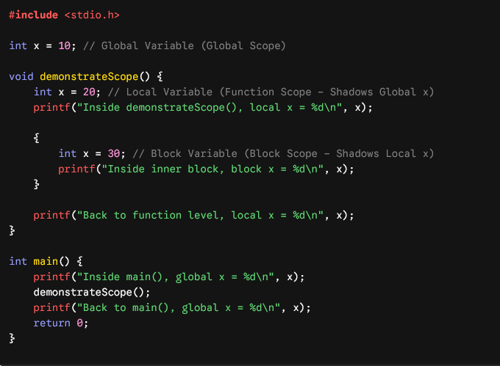
Example 1: Demonstrating Lexical vs. Block Scope in C

Example 2: Static vs. Automatic Storage Duration (Binding & State)

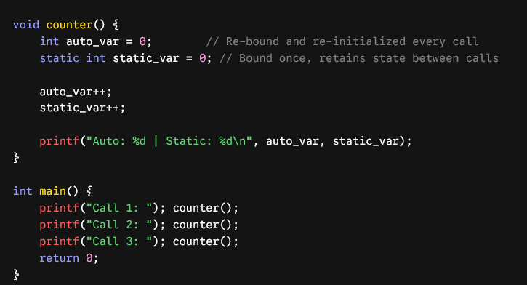

Lab Activities:

Activity 1: Environment and State Tracking
Predict the output of the following C program by tracing the environment (variable bindings) and state (stored values) at each line. Write the output and explain how block scoping affects the environment.
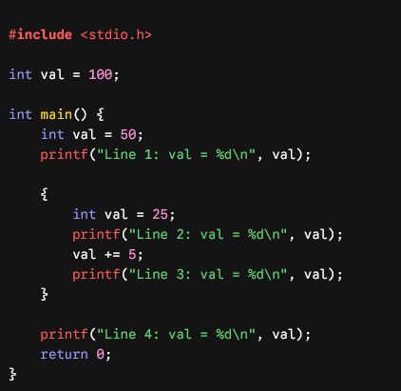

Activity 2: Environment Setup Verification
Open your terminal/command line and compile your code using GCC directly:
- Open terminal and run: gcc --version
- Save your file as scope_test.c.
- Compile using: gcc scope_test.c -o scope_test
- Run the executable: ./scope_test (Linux/Mac) or scope_test.exe (Windows).

Lab Exercises:

Exercise 1: Nested Scope Resolution Simulator
Write a C program with at least three levels of nested block scopes inside main().
- Declare a variable int count at global scope and in each block level.
- Assign distinct initial values to count at each level.
- Print the address (&count) and value of count inside each block level to verify how memory locations (l-values) differ even when variable names are identical.

Exercise 2: Simulating a Simple Symbol Table
Write a C program that simulates a basic Symbol Table record for scope binding using a structure:
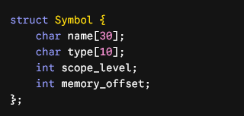
Define an array of 3 Symbol structures, populate them with dummy variable entries (e.g., x, y, z at different scope levels), and print the symbol table contents in a formatted tabular layout.

Exercise 3: Dynamic Scope vs. Static Scope Analysis
C uses Static (Lexical) Scoping. Analyze the following code snippet:
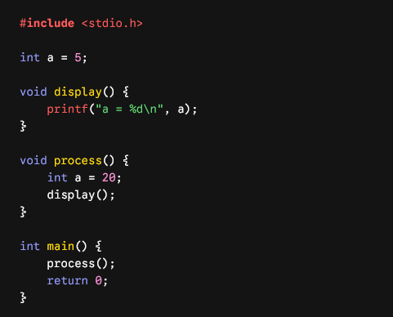
• Task A: Compile and run the program. What is the actual output?
• Task B: Explain why the output is obtained under C's Static Scoping rules.
• Task C: If C used Dynamic Scoping (resolving variables using the calling stack rather than text structure), what would the output have been?

